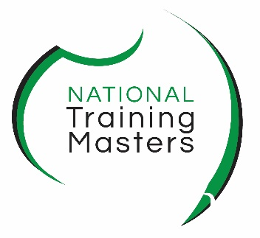
Emergency Contact Form
Confidential and Private

Please complete this form as part of your orientation. Type in the form directly and sign, as a digital form your name is sufficient as a signature. Use the highlighter to selecy responses.
Course |  | Location
First Name |  |  | Surname
Delivery | Face to face, Flexible, Hybrid, workplace, school, online
Residential
Address
Date of Birth |  |  | Mobile
E-mail

I. EMERGENCY CONTACT (required): please provide the name of the person we should contact in the event of an emergency during your studies at NTM. Provide as much contact information as possible. We will only use this information to contact your nominated person in cases such as a medical emergency, bush fire, flood or other emergency. Remember to inform your nominated person you are studying at NTM.
Primary Emergency Contact Name
Relationship
Mobile |  | Work

II. HEALTH/WELFARE INFORMATION (optional):
To help ensure availability of appropriate services while at NTM, feel free to share with us the following information.
Just highlight yes or no. Provide details if you answer Yes, these questions are optional |  |  | Please provide details:
Are you currently receiving medical or psychological care of which you want us to be aware? | No | Yes
Is there anything in your medical or psychological history of which you want us to be aware?  (for example, need for allergy shots, chronic condition). | No | Yes
Do you anticipate needing any assistance while on site (including classroom or training) due to a documented disability? | No | Yes
Do you have any caring responsibilities? (including children, family members and those with a disability, this may affect you starting or ending at different times) | No | Yes

You can update these contact details by simply going into Teams > Assignment and updating the contact information or email admin@ntm.edu.au or call 1300 653 501

Date
Your Name

